Wilkinson power divider development
Xinhang Xu
8/26/2026
- Calculate the impendence on each trace through Wilkinson101_Rev1.3.xls
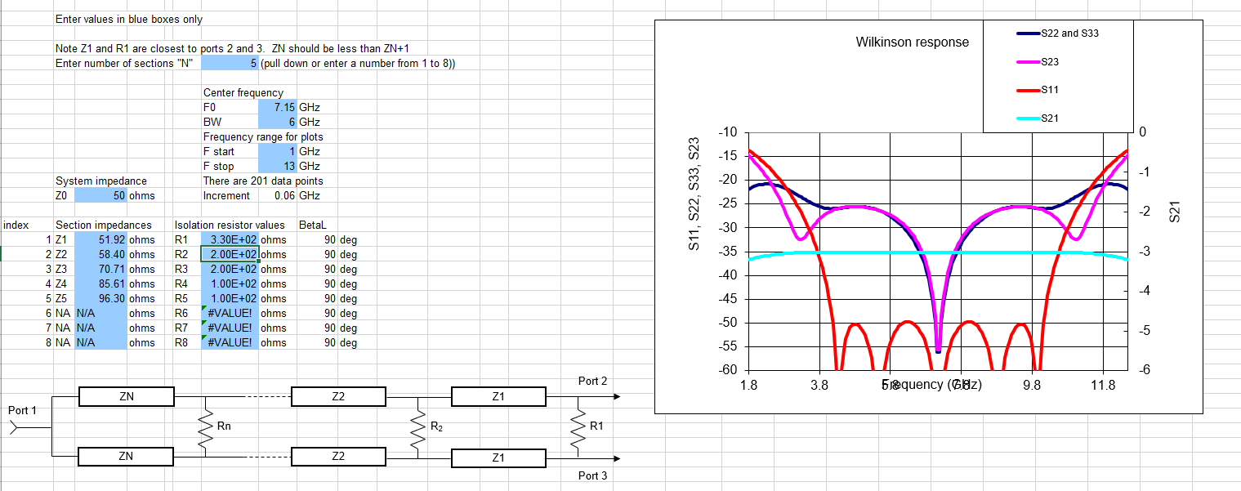

- Calculate the width of the microstrip for specifical impedance.

1. There are two different dielectric constant value for calculating the impedance of microstrip:
(a). Data from R04350B datasheet, which is about 3.73 at 7GHz
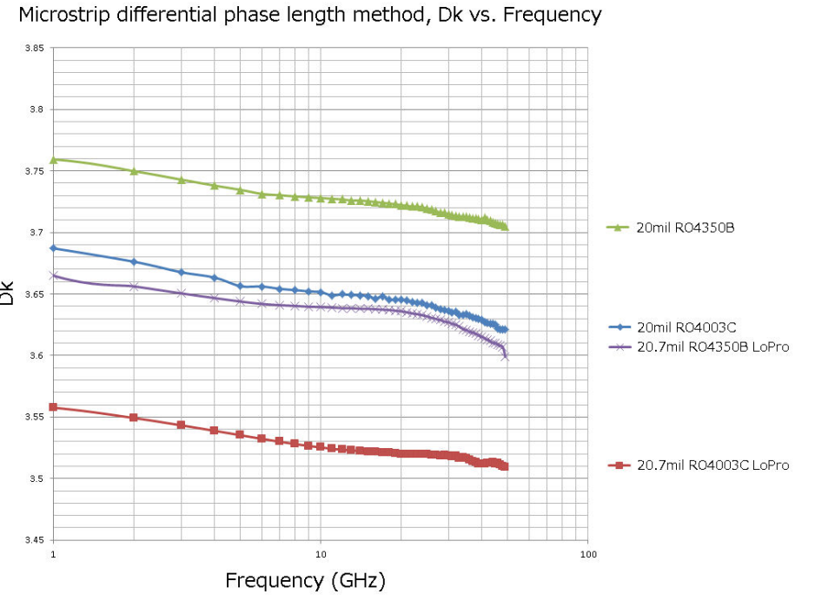
Figure 1. Dielectric constant
(b). Data from CST software, which is 3.66 , as shown in Figure 2. Which value should I filled in
For the microstrip impedance calculation?
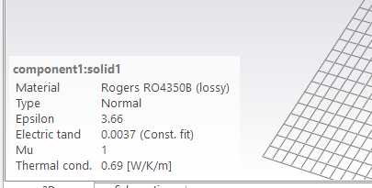
Figure 2. Dielectric constant from CST

Claude answer:
Use 3.66 — the value already loaded in your CST material (component1:solid1), not the 3.75 you're reading off the datasheet plot.
Here's why these two numbers exist and disagree:
The datasheet actually lists more than one Dk, and they're not interchangeable:
- Process Dk = 3.48 ± 0.05 — measured by clamped-stripline resonator at 10 GHz. This is a QC/process-control number, and the clamped-stripline method can potentially lower the actual dielectric constant due to the presence of an air gap. Jlcpcb
- Design Dk = 3.66 — measured 8 to 40 GHz by the differential phase length method, and this is the number Rogers explicitly intends for circuit/impedance design. MCL PCB
The 3.75 you're seeing is most likely from the datasheet's Dk-vs-frequency dispersion curve (which is thickness-dependent and drawn from a different characterization set), not the tabulated design value. It's not meant to be plugged directly into a simple impedance calculator.
For a field solver / impedance calculation, always use the design Dk (3.66): the 3.48 figure is the process Dk measured via clamped stripline resonator, and it is not the value you should plug into your impedance solver — Rogers recommends design Dk of 3.66 for impedance modeling on microstrip and stripline. Engineers who plug the lower process value into a solver systematically get traces too narrow and impedance too low: using 3.48 in an impedance calculator gives traces that are too narrow. MediumPCBSync
On frequency :RO4350B's Dk is intentionally very flat across the microwave band — RO4350B provides a stable Dk of 3.48 from 500 MHz to over 40 GHz with minimal variation versus frequency (the corresponding design-Dk figure being 3.66 over the same range). So you don't need to chase a frequency-corrected value for 7.1 GHz — 3.66 at 2 GHz and 3.66 at 7.1 GHz are the same design value; dispersion in this material over that span is small enough to ignore for a thin-microstrip Z₀ calculation. RayPCB
So: set eps_r = 3.66 in the Impedance Calculation dialog — it matches what CST's material model is already using, so your 3D build and your quick hand-calc will stay self-consistent.

  - Process Dk = 3.48 ± 0.05 (10 GHz, clamped-stripline, QC test)
  - Design Dk = 3.66 (differential phase-length method, 8–40 GHz band) — (cite index="3-1">measured across 8 to 40 GHz by the Differential Phase Length Method</cite>, i.e. it's already the value Rogers derived to be representative across that whole microwave range, not a single-point 10 GHz number.

2. There are two different tool for calculating the impedance of microstrip: KiCAD and CST
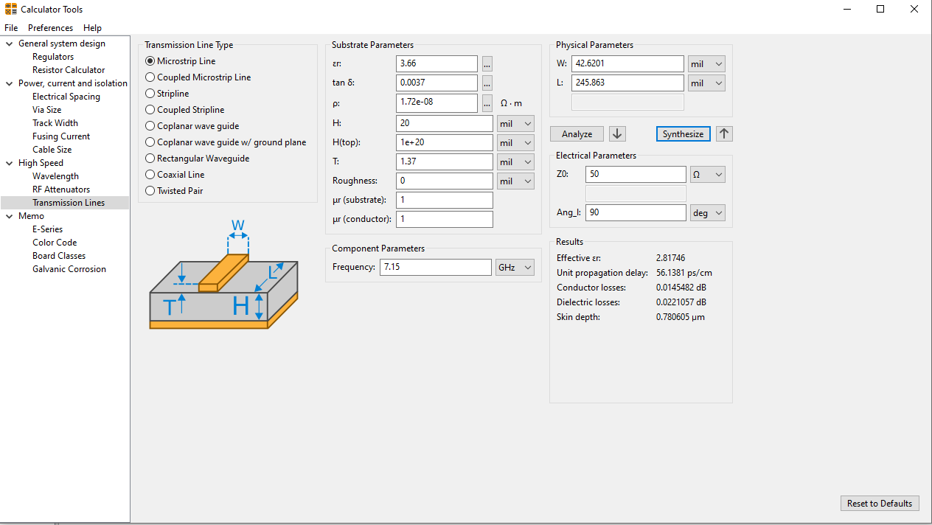
Figure 3. Calculator tools in KiCAD for Z0 =50 ohm
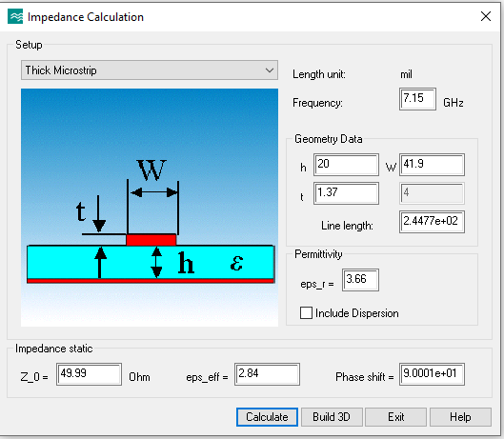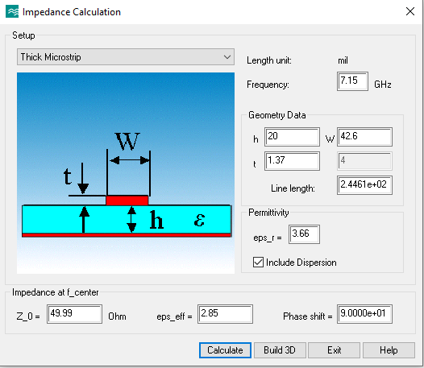
Figure 4. Impedance calculation tool from CST, we should consider the structure dispersion with Include dispersion selected.
Since two tools show two different L required for 90 phase degree, I prefer to use results from CST module.

- Draw the Wilkinson power divider through KiCAD footprint (refer to link). Here I give a datasheet for WPD1 from Figure 14.
Table 1. Trace width and length on each stage (4 stage), calculated from CST
Z0(90 degree) | W(mil) | L(mil)
52.55 | 38.65 | 395.82
62.47 | 28.05 | 400.46
80.04 | 16.28 | 407.40
95.14 | 10.15 | 411.76
50 | 42 | **


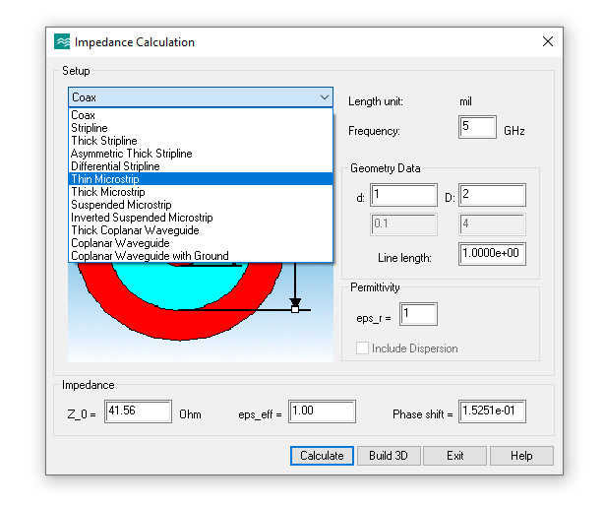
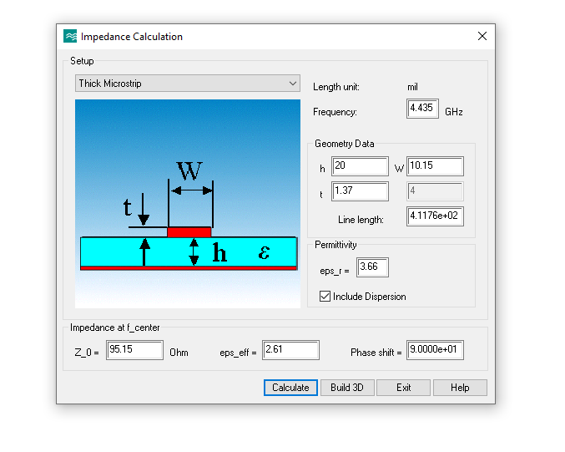
(KiCad library Resistor_SMD, footprint R_0402_1005Metric) has pads with centers that are 20.08 mil apart with dimensions of 21.26 mil and 25.2 mil. The gap between the two pads is 40.16 – 21.26 = 18.9 mil, which needs to be maintained (no metal between y= -9.45 and +9.45 mil)

- Open the Python code wilkinsonPD_drawing_v2.py (link) and Kicad footprint editor, add a new footprint, add two SMD pad with size 25.2mil * 21.26 mil and place the center on (0, 20.08) mil and (0, -20.08)mil.

- In the python code, to calculate coordinate of the first ring, fill in the correct number of trace width, trace length, pad size, end position of the trace on the right side of the arc, and the angle of the arc in trace1, as shown in Figure 6.
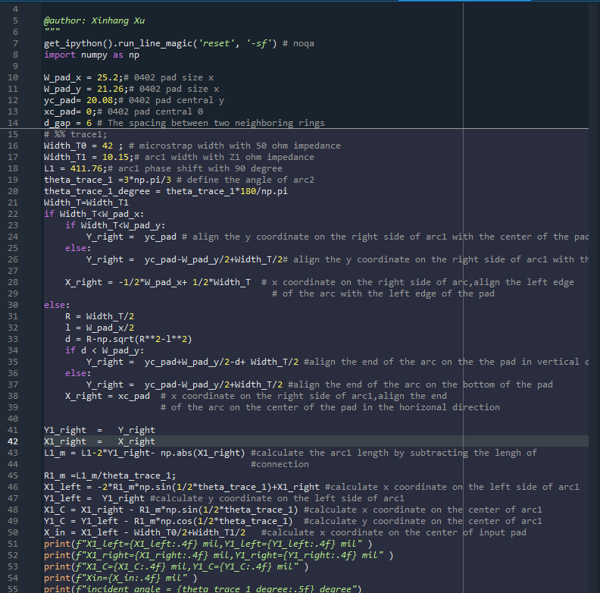
Figure 5. Trace coordinate calculation for Wilkinson Power Divider
- Record the output data and fill in the KiCAD arc setup
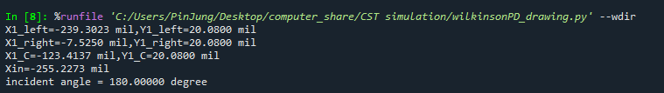
Figure 6. The coordinate of the ring on the first stage

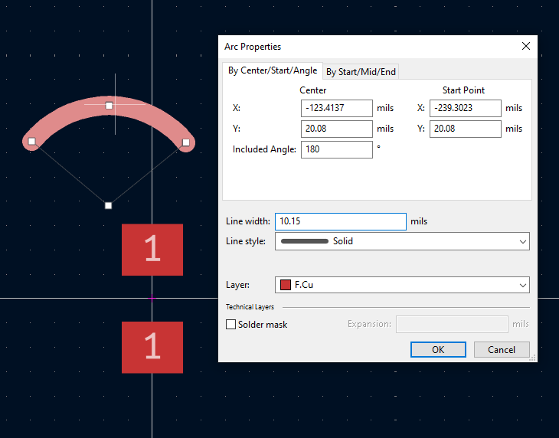
Figure 7. The arc setup in the kicad
- Duplicate the arc and set the arc in the same position, reverse the y position for all the coordinates you will get a mirror are about x axis.
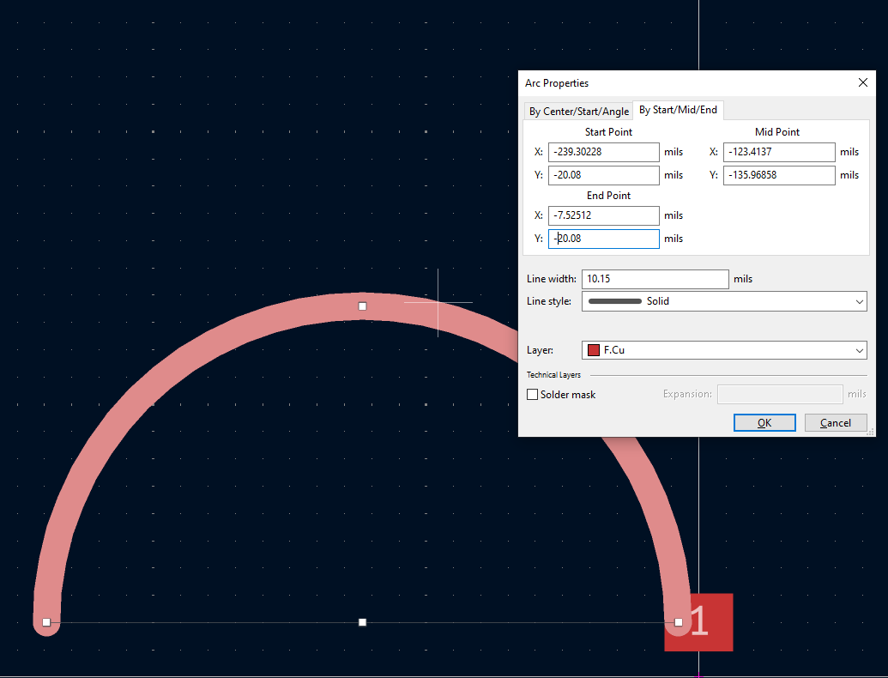
- Add the input pad at X=Xin, Y=0 with the size size (Width_T0, Width_T0).This completes the
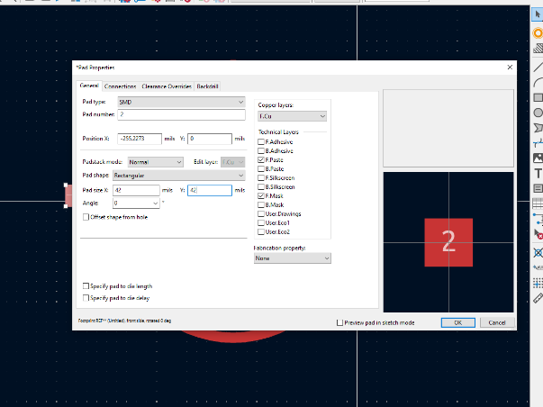
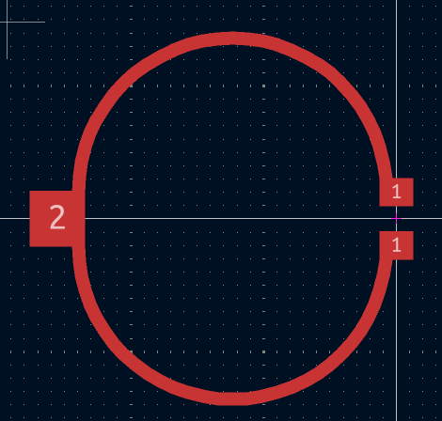
first stage.
- Calculate the position of the second ring in code trace 2 by filling in the trace width, trace angle and trace length.
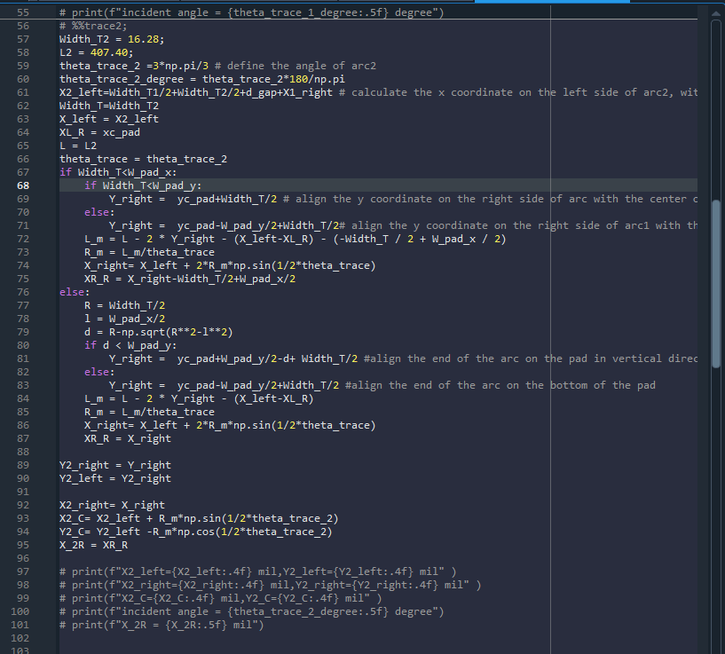

- Repeat the step c, d for the second ring.
- Line up the bottom of the left resistor with the left side of the trace;
- 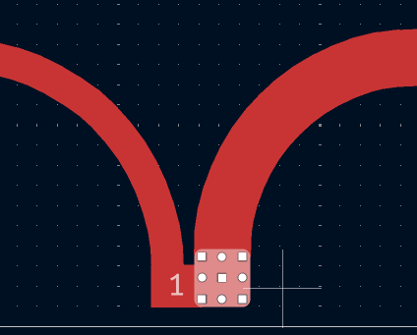
- Add two SMD pad with size 25.2mil * 21.26 mil and place the center on (X_2R, 20.08) mil and (X_2R, -20.08) mil.
- Keep the same steps f,c,d, g and h,i* for the rest of the rings until all the rings finish.
- After finishing all the rings,create 50 Ohm traces which line up on the R resistors, taking care that none of the trace falls in the gap between the resistor pads or inside the arc. The other end of the trace should extend to Y= ±36 mil, adjusting the X-point (integer value please!) so that you have a roughly 90 degree angle between this trace and the arc. Place the output pads on the end of these traces.
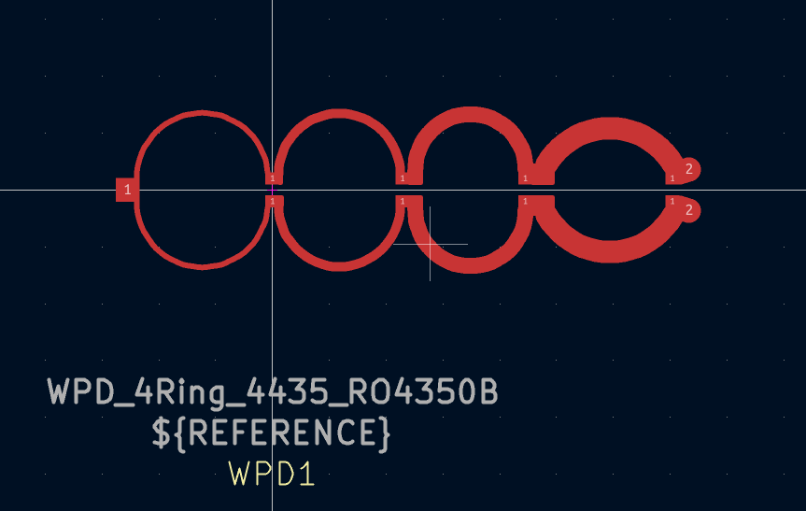
- Finally, reset the pad number
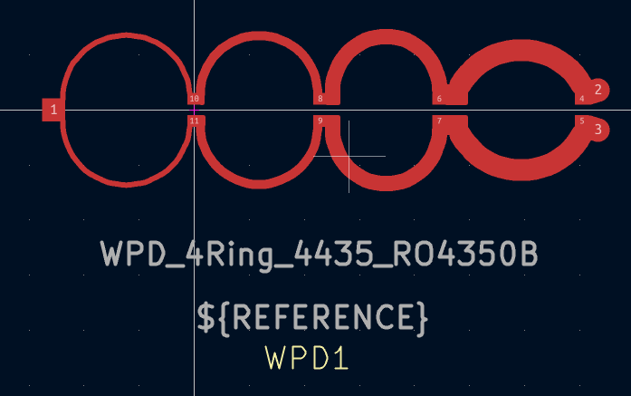
- Export the gerber file to CST for simulation (list detail steps)

- Export the gerber file from kicad, only need F.Cu layer
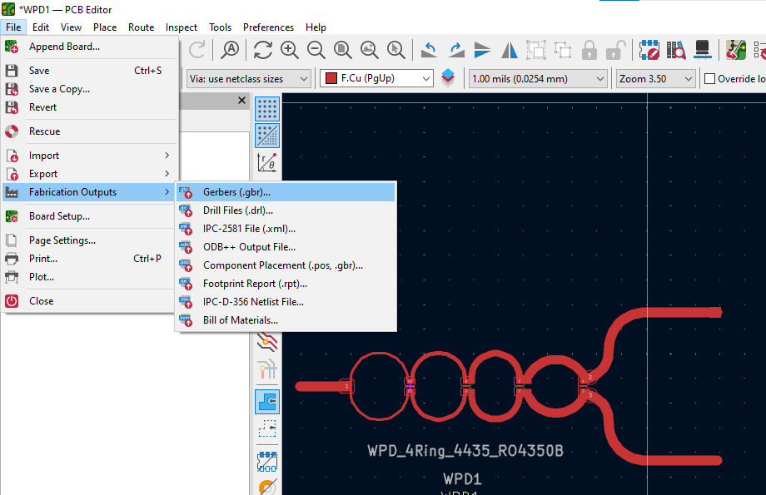

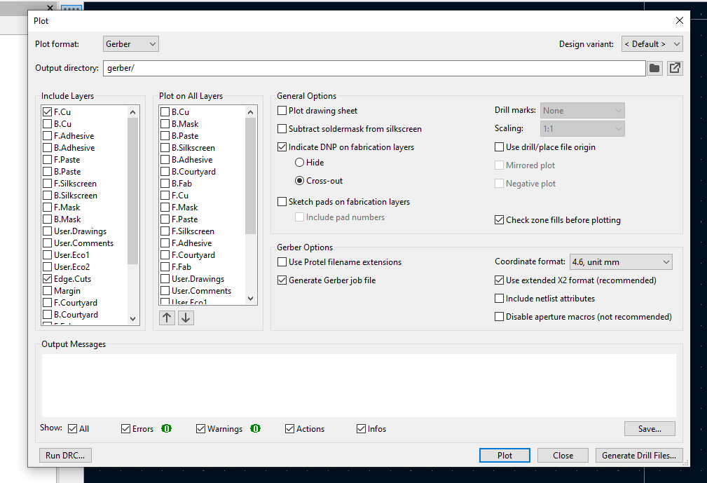

- Open CST, import the gerber file into CST

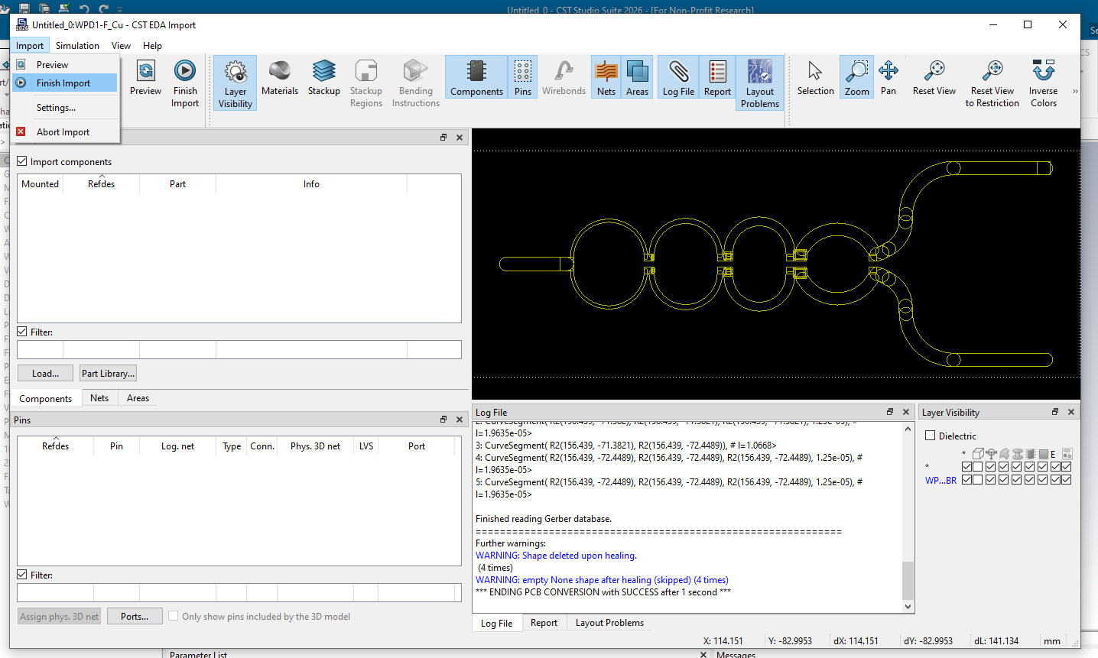
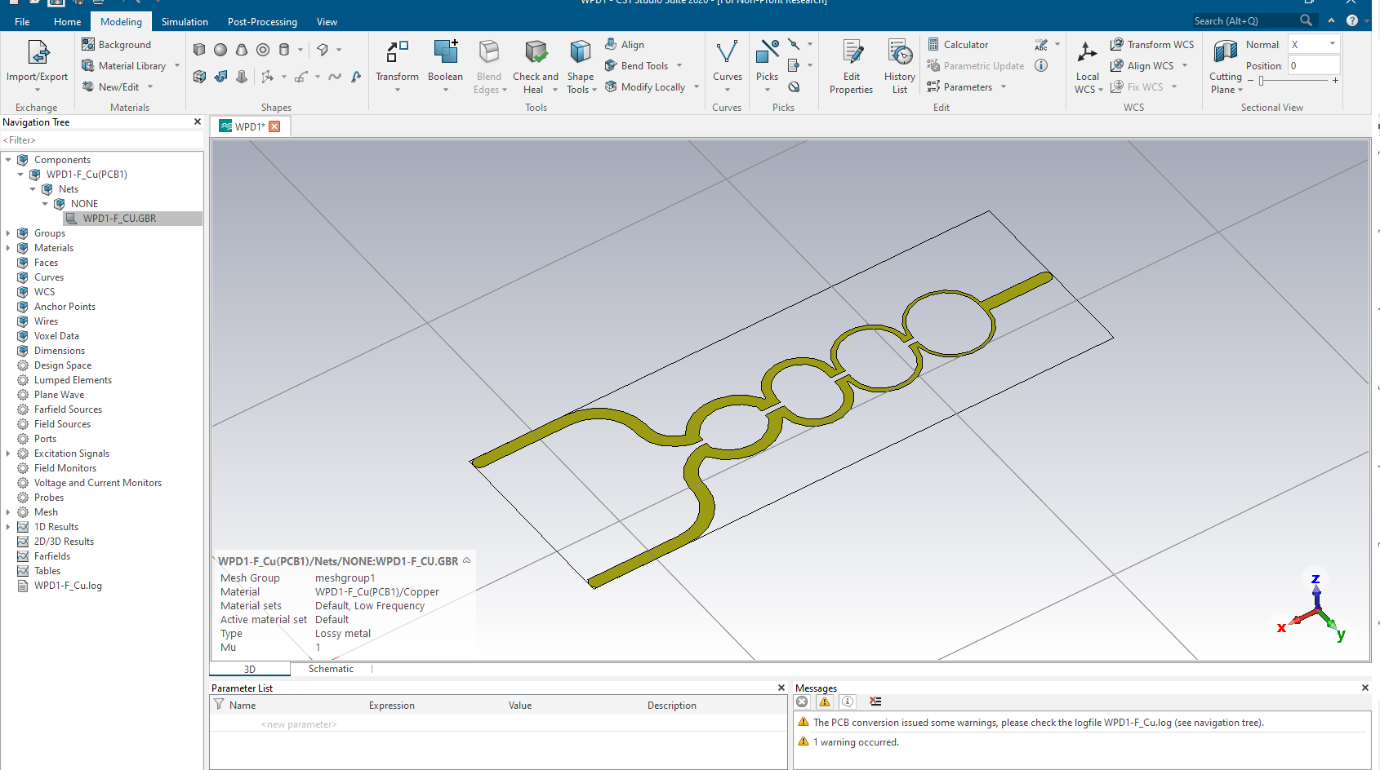

- Create the 3d trace by selecting the surface and extruding the face with 1oz (1.37 mil) heigh.
- Create the dielectric brick under the trace with 20 mil thickness RO4350B material
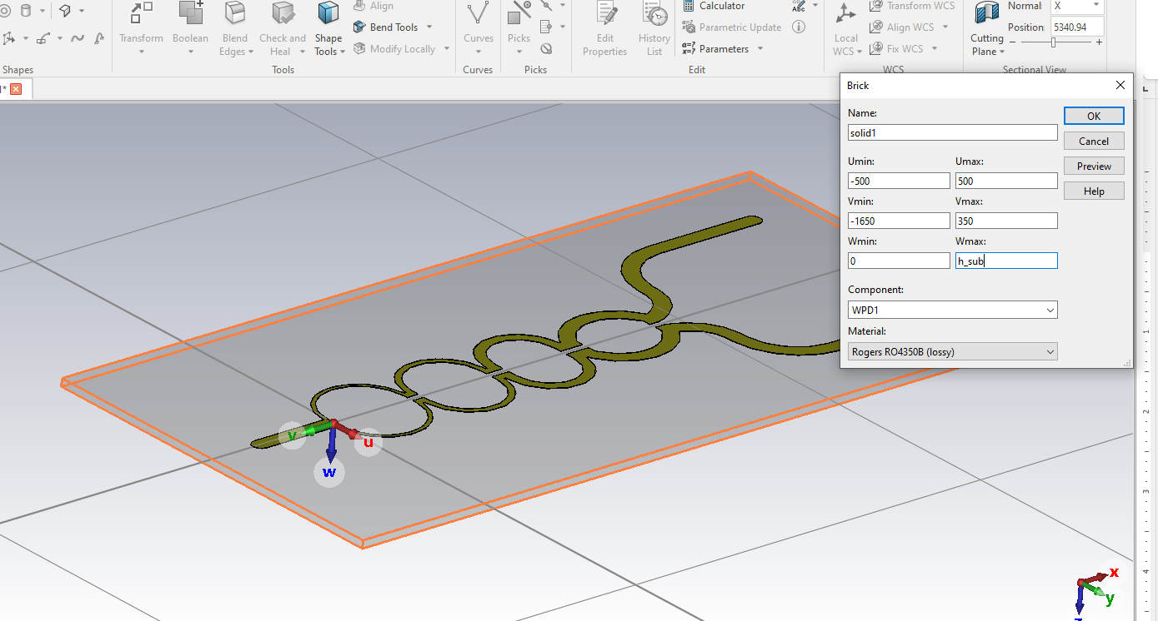
- Create the ground under the trace with 1.37 mil thickness, Copper material
- Create the brick to do the subtract Boolean calculation at the input port and output port to get a flat surface at the port
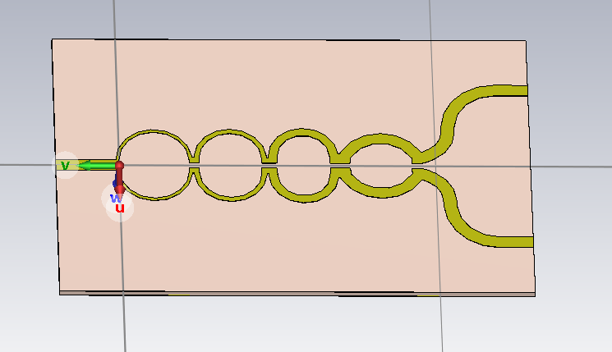
- Add resistor on each pad by selecting the two points for resistor position (Pick point) and then adding lumped element
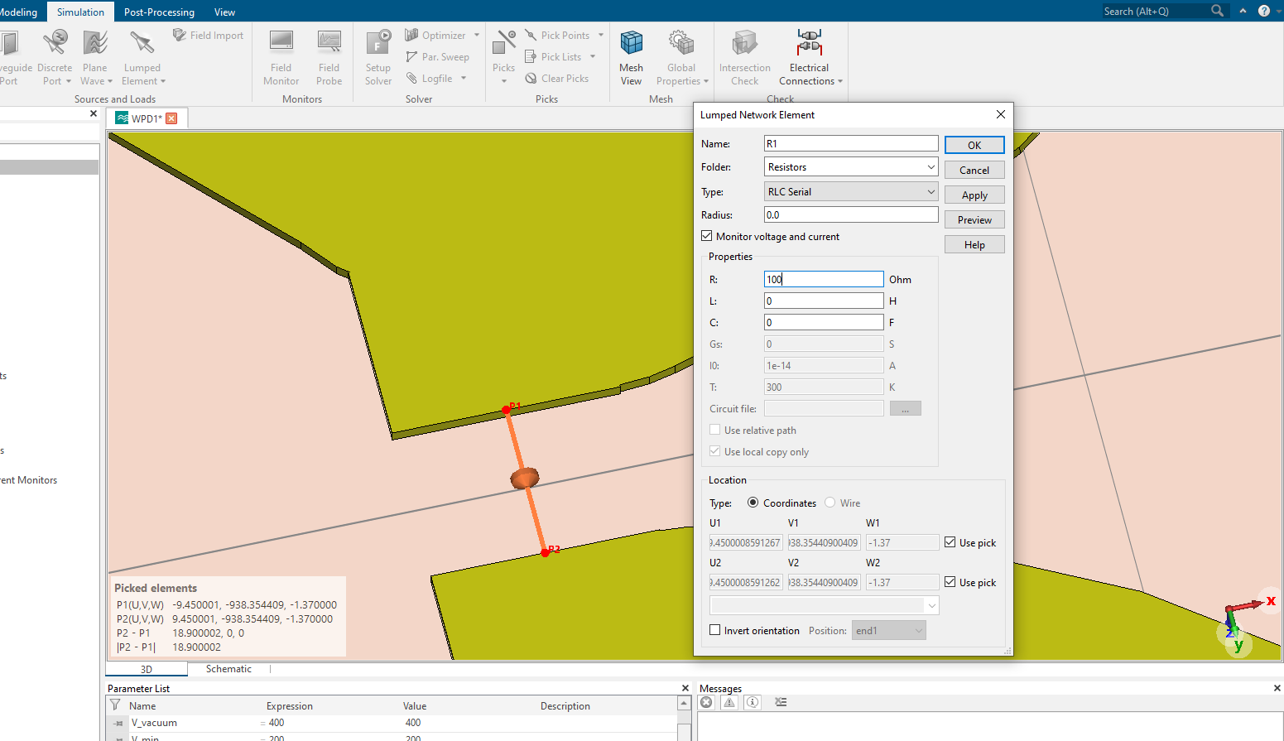
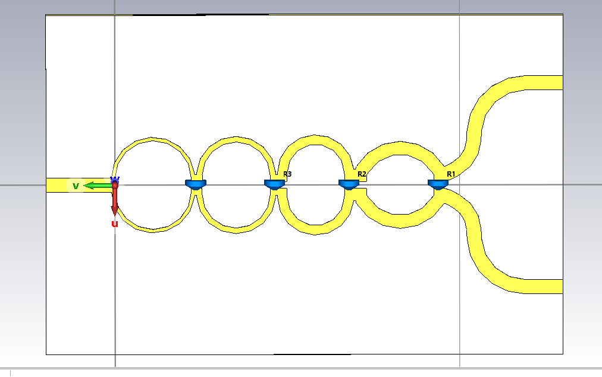
- After adding the resistors, Create the input port and output ports
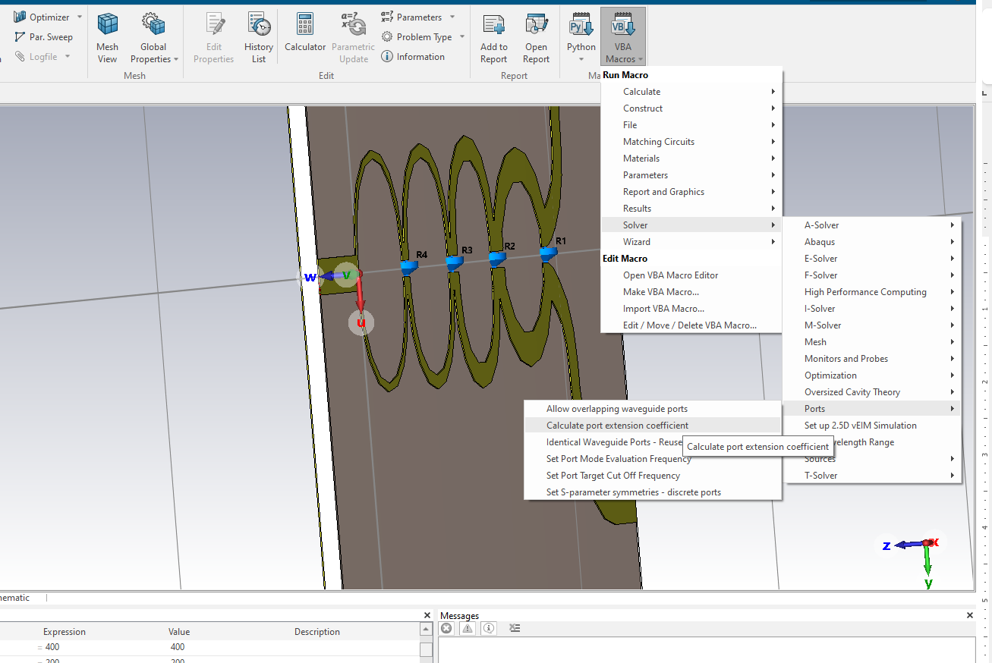
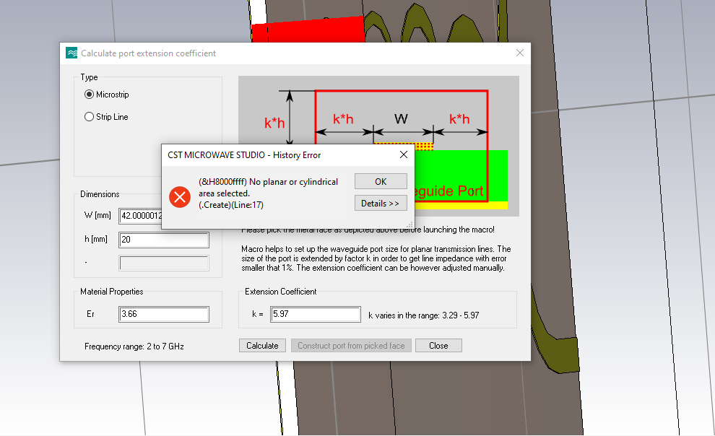
- You will see the error, just click ok and close the Calculate port extension coefficient, then go to Modeling, History list and click update, the port will be created automatically. Same way for port 2 and port 3
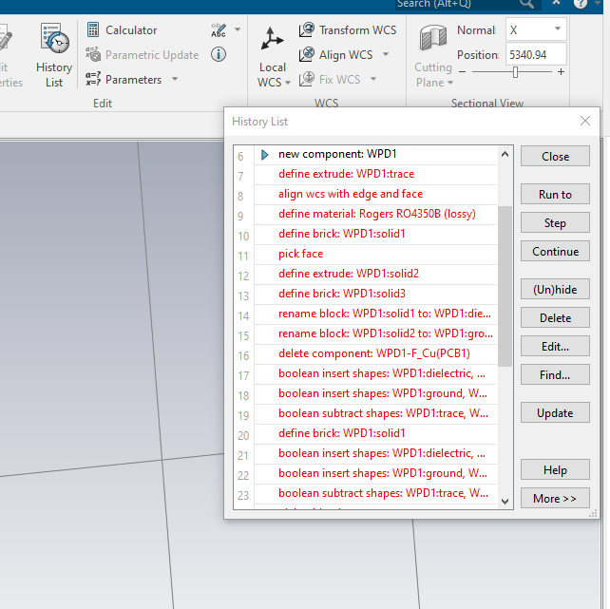
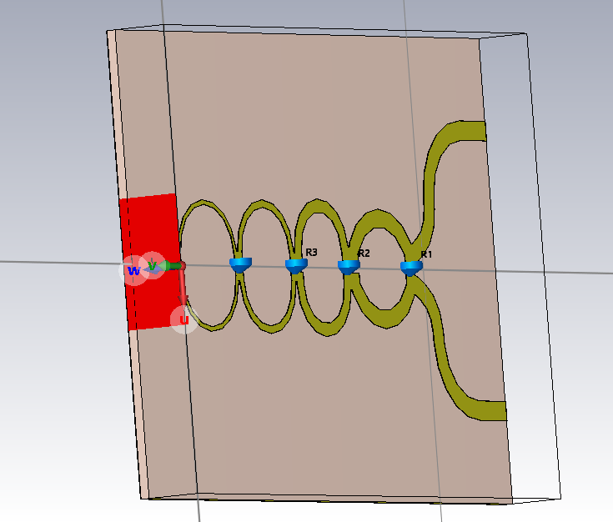

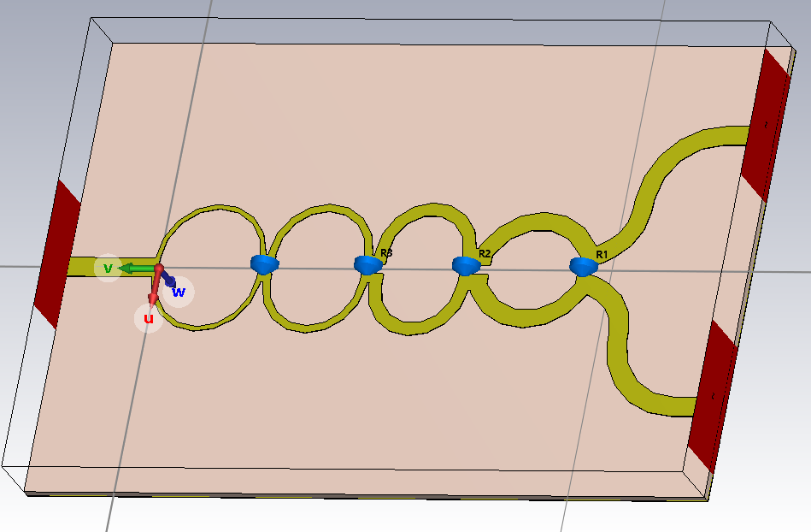
- Set the boundary conditions in Simulation,Boundaries

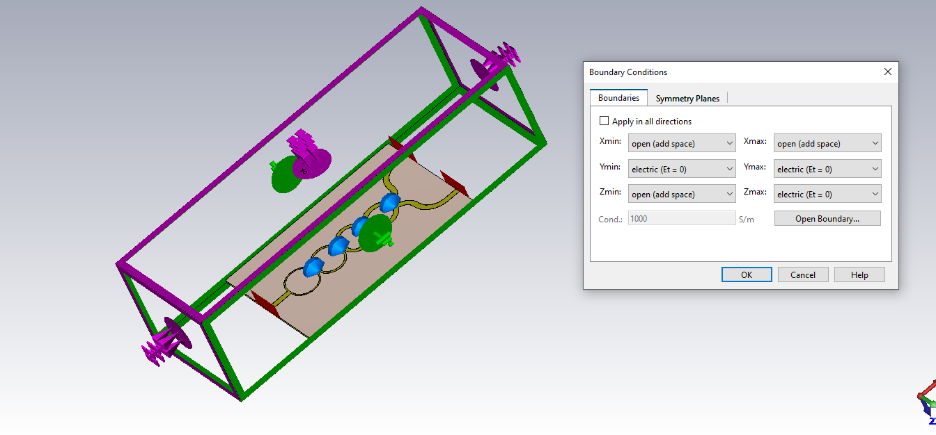
- Setup solver and then start the simulation
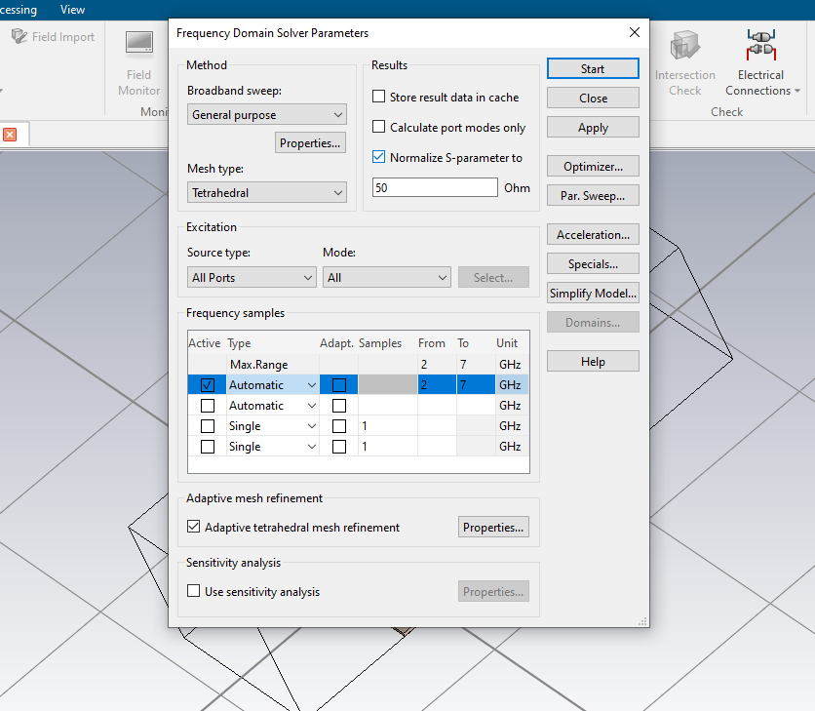

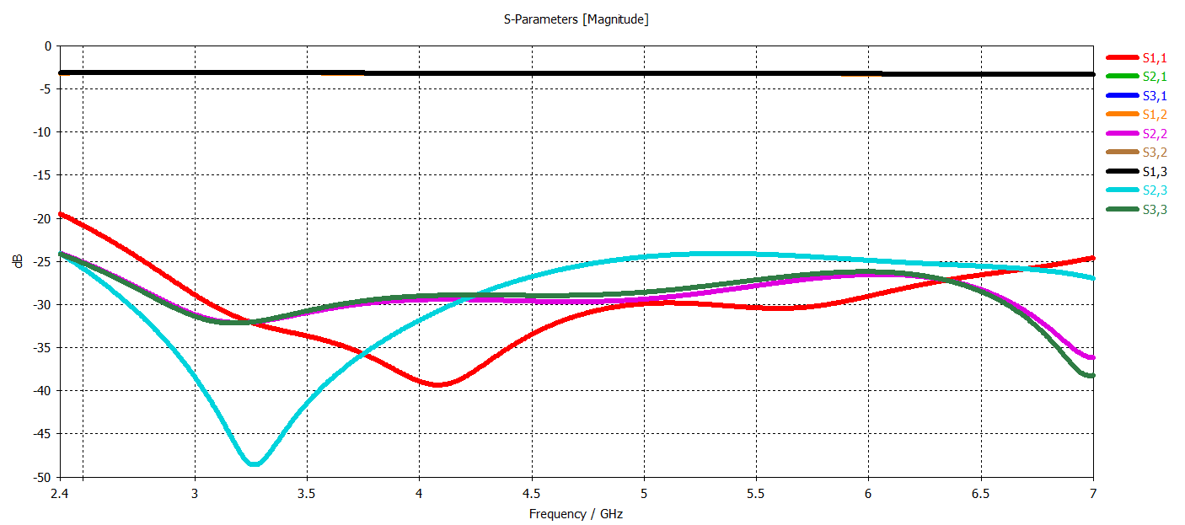

Figure 8.Simulation results with R1 = 330 ohm,R2=200 ohm,R3=100 ohm,R4=100 ohm
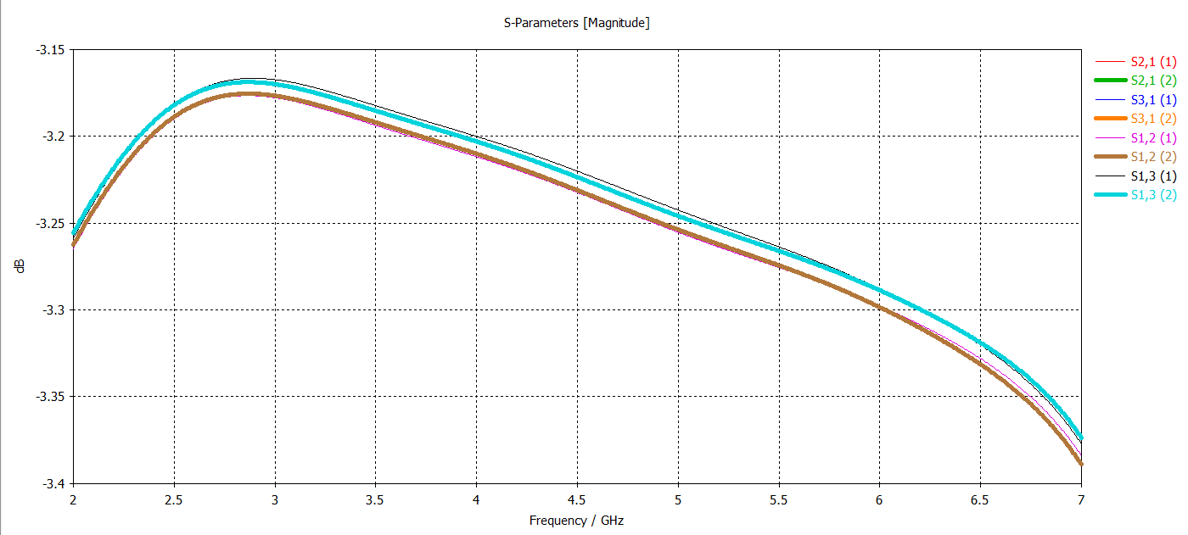
Figure 9.Simulation results with R1 = 330 ohm,R2=200 ohm,R3=100 ohm,R4=100 ohm
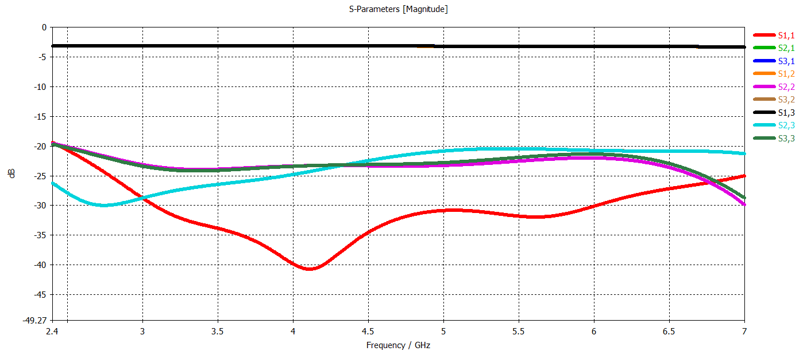
Figure 10. Simulation results with R1 = 200 ohm,R2=200 ohm,R3=100 ohm,R4=100 ohm

The WPD design for NSF ECE system:
- The VCO frequencies on 8 channels
Table 3. VCO frequencies distribution
Channel | CH1 | CH2 | CH3 | CH4 | CH5 | CH6 | CH7 | CH8
Center frequency (GHz) | 2.40 | 3.76 | 5.11 | 6.47 | 7.83 | 9.19 | 10.54 | 11.90

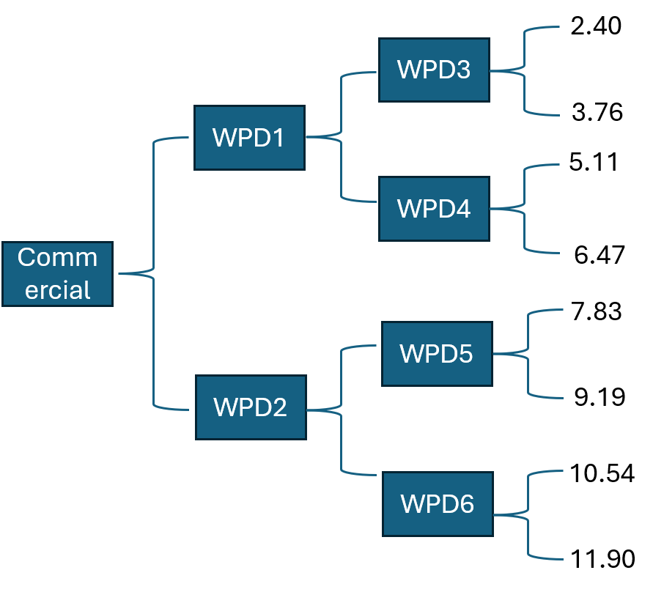
Figure 11. WPD setup on RF board
WPD1 : 2.4-6.47 GHz
WPD2:7.83-11.9 GHz
WPD3: 2.4 – 3.76GHz
WPD4:5.11-6.47 GHz
WPD5:7.83-9.19 GHz
WPD6:10.54-11.9GHz

Table 2. Trace width and length for 4 stages
Z0(90 degree) | W(mil) | L(mil)
52.55 | 38.65 | 395.82
62.47 | 28.05 | 400.46
80.04 | 16.28 | 407.40
95.14 | 10.15 | 411.76
50 | 42 | **

WPD1 design (2.4-6.47 GHz)
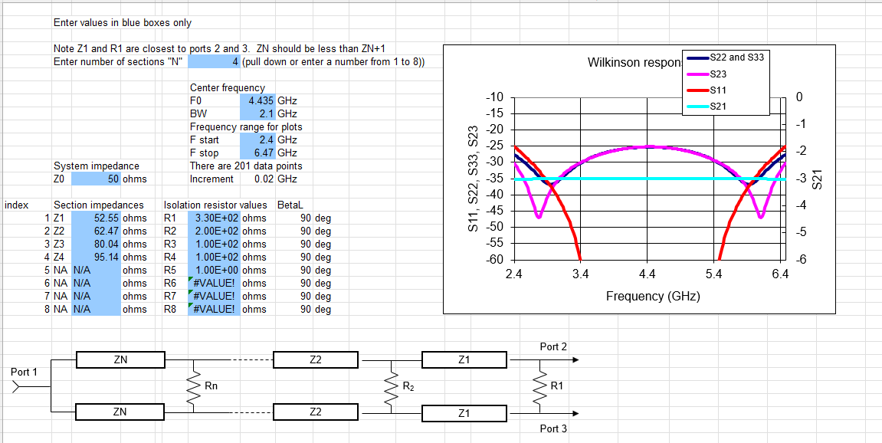
Figure 12. WPD1 parameters

